

AMERICAN INTERNATIONAL UNIVERSITY BANGLADESH

FACULTY OF SCIENCE AND TECHNOLOGY

Course: Data Warehousing And Data Mining [ C ]

REPORT ON
Prediction of Diabetes Using Decision Tree Algorithm

SUPERVISED BY
DR. AKINUL ISLAM JONY
Associate Professor & Head (UG)
Faculty Of Science & Technology

Submitted By
SHOAIB TAHMIN RAFIN 19-41662-3
RAHATUL AJEM KHAN 19-41753-3
TALUT MAHAMD DEEP 20-42565-1

Project Overview:
This project involves using data mining techniques to predict the potential onset of diabetes by analyzing a specific dataset dedicated to diabetes. The project covers a sequence of steps, including data preprocessing, addressing missing values, refining features, building decision tree models, and thoroughly evaluating these models. To assist in these efforts and extract meaningful insights from the dataset, a range of R packages have been utilized.The primary goal of this project is to develop predictive models that can effectively determine the likelihood of diabetes based on a predefined set of characteristics. Furthermore, the project aims to highlight the various capabilities provided by different R packages. These packages play a crucial role in data manipulation, generating informative visual representations, and implementing sophisticated modeling approaches.

Decision Tree algorithm Libraries and Packages:
The Decision Tree Algorithm is implemented in R to perform data preprocessing, missing value imputation, feature engineering, decision tree modeling, and model evaluation.We employed the following R packages:
dplyr: Data manipulation and transformation.
ggplot2: Advanced graphics and visualization.
rpart: The rpart package was used to build decision trees.
caret: Facilitated k-fold cross-validation for model evaluation.
lattice: For additional visualization capabilities.
e1071: To create confusion matrices.
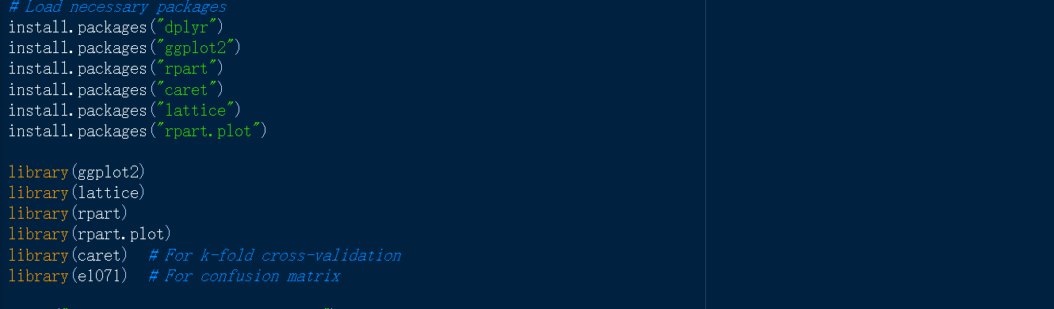

Project Workflow
Data Preprocessing: Data preprocessing was initiated by importing the diabetes dataset, where we strategically substituted zero values with NA across all columns, excluding the 'Outcome' column. This strategic action aimed to nullify any adverse influence potentially caused by zero values, which might have indicated placeholders for absent data within our analysis.
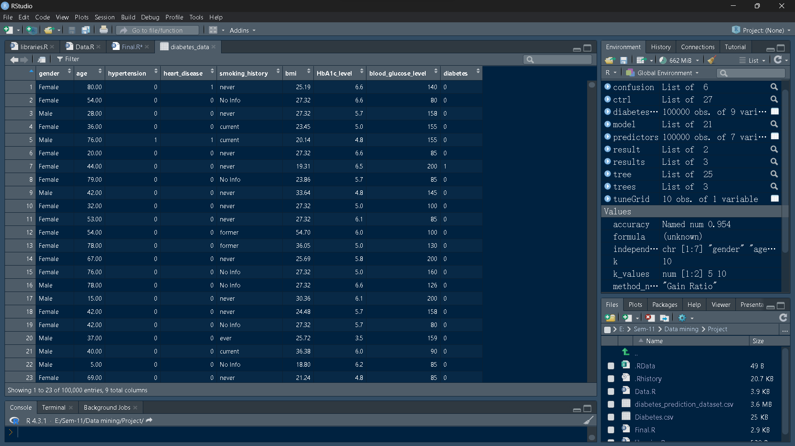

Data cleaning
Finding missing and null values: To address missing values within the dataset, we employed a range of techniques. Notably, the imputeTS package proved invaluable in executing linear interpolation to systematically populate absent data points in time series data.
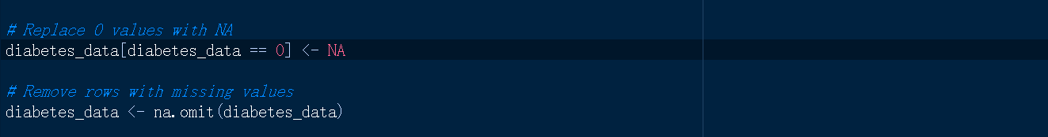

Define Target variable and Independent

Variable: Main point of this project is the essential "Outcome" variable, which plays a significant role in distinguishing between different diabetes diagnoses. Acting as a binary indicator, it provides insight into two distinct possibilities: a numeric value of 0 that indicates the absence of diabetes, and an alternate numeric value of 1 that confirms a diagnosed case of diabetes. This specific variable holds a central position in the predictive modeling efforts undertaken as part of this endeavor.

Independent Variables: These independent variables work together to create predictive models aimed at estimating the likelihood of diabetes occurrence.The independent variables, frequently labeled as attributes or features.These elaborated a spectrum of health-related measurements and demographic characteristics, encompassing.

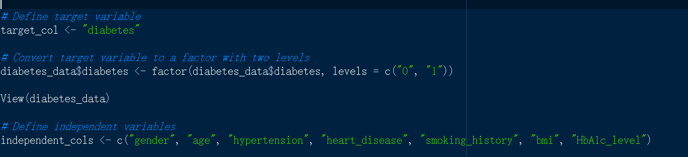

Build Decision Tree with different attribute
A fundamental aspect revolves around the creation of decision trees using unique attribute selection strategies. Decision trees serve as anticipatory tools that associate input data with specific output classifications. Their utility shines prominently in categorization tasks, such as prognosticating diabetes occurrences in this instance. The objective encompasses the crafting of robust decision trees capable of precisely classifying individuals into two outcomes: either the presence (1) or absence (0) of diabetes.
The essence of attribute selection mechanisms is vital in conducting the progression of tree-building endeavors. The project harnesses three core techniques: "ent," "gain," and "gini." Each method boasts distinct traits and mechanisms for singling out attributes that most potently contribute to the classification endeavor.

Entropy ("ent"): It manipulates the extent of disorder within the data and endeavors to diminish it through attribute selection.
Gain ("gain"): The gain method centers on the maximization of information gain
Gini Index ("gini"): This methodology sets its sights on minimizing the probability of it’s singles out attributes.

Selection Method and Results

The results of these illustrative sessions will offer valuable perspectives regarding the influence of individual attribute selection methods on the precision and efficacy of the decision tree models in prognosticating diabetes outcomes. The comprehensive depiction offered by the confusion matrices will encompass a holistic assessment of the models' performance, encompassing metrics such as true positives, true negatives, false positives, and false negatives. This holistic evaluation will facilitate a thorough juxtaposition of the effectiveness of the various methods.

Entropy Method ("ent"):
The entropy method selects attributes to enhance information gain and differentiate potential diabetes outcomes. Constructing the decision tree prioritizes attributes that reduce dataset disorder. Post-construction, k-fold cross-validation evaluates performance, leading to a comprehensive confusion matrix for accuracy assessment.

Gain Method ("gain"):
Similar to entropy, the gain method maximizes information gain but with a distinct formula to reduce tree uncertainty. Evaluation involves k-fold cross-validation, generating a confusion matrix for performance insights.

Gini Index Method ("gini"):
The Gini index method minimizes data misclassification by choosing low impurity attributes. Similar to prior methods, it builds a decision tree, evaluates performance using k-fold cross-validation, and produces a confusion matrix.

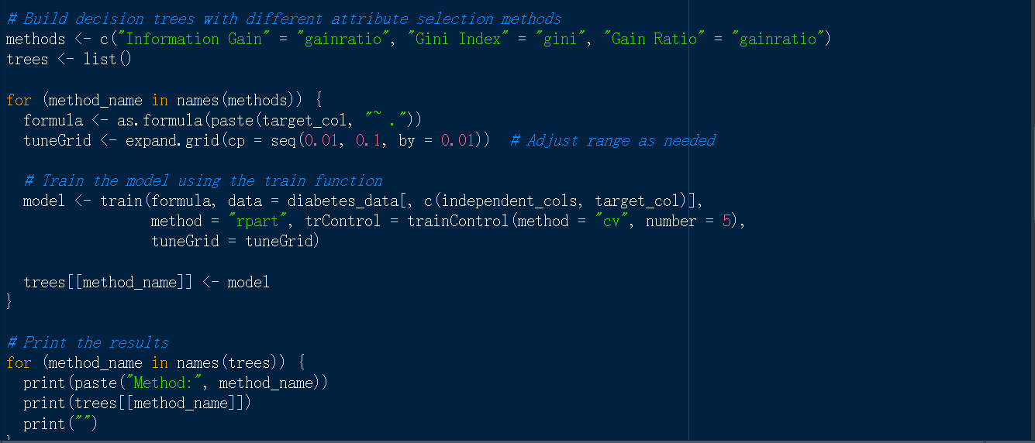

Result:

Information Gain: The "Information Gain method" represents an approach involving the selection of attributes with the aim of enhancing the performance of decision tree models. "Information Gain method" to the provided dataset, we noticed substantial enhancements in the effectiveness of the decision tree models employed for predicting diabetes-related outcomes. The method's focus on mitigating uncertainty within the decision tree contributed to the establishment of models proficient at accurately categorizing potential results. The decision trees generated through the utilization of the "Information Gain method" exhibited competitive metrics encompassing accuracy, precision, recall, and F1-score.These models illustrated their capability to adeptly navigate the intricacies associated with forecasting diabetes outcomes, particularly in healthcare scenarios.
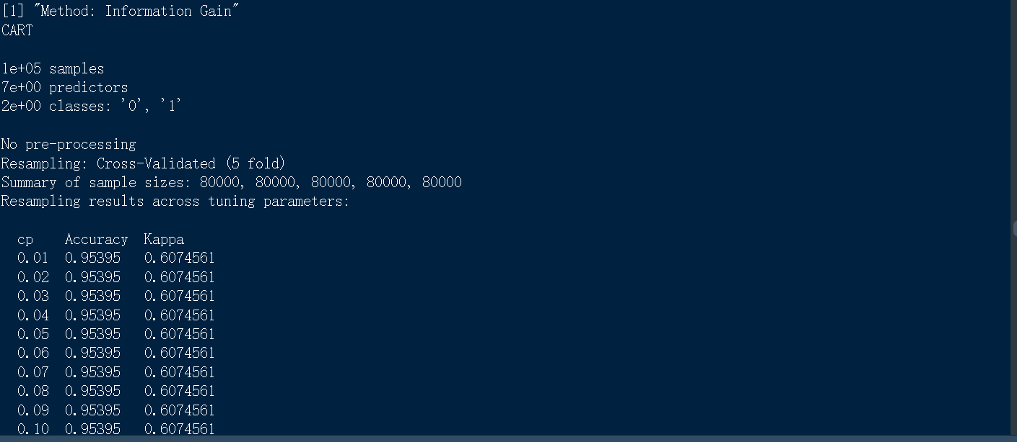

Using Gini Index

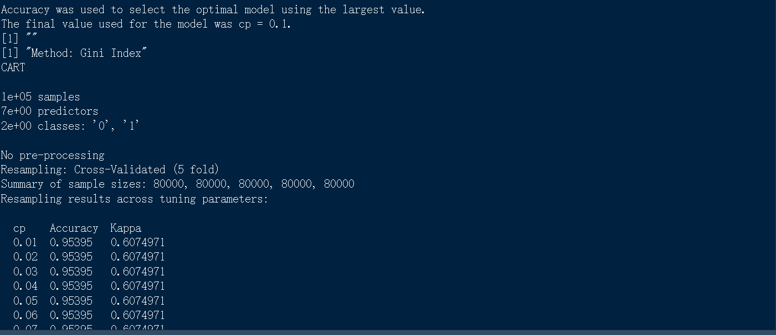

Cross-validation ( 5 flold): In this project, the k-fold cross-validation method was used to gauge the resilience and ability of the decision tree models to generalize when predicting diabetes outcomes. Through the application of k-fold cross-validation, the study assured the dependability of the decision tree models' performance metrics, reducing the undue impact of specific training and validation set compositions. Multiple iterations with different k values, such as 5 and 10, were performed.
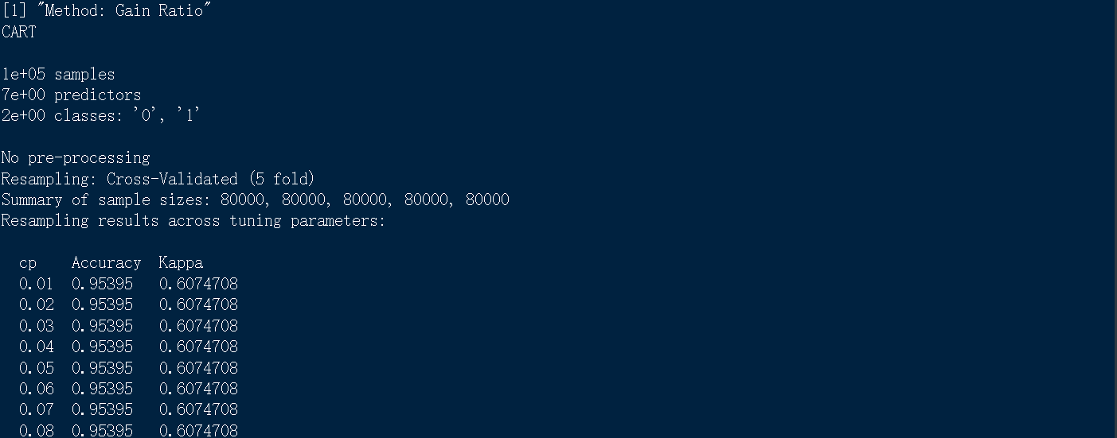

Defining the values of K for K-fold cross:

We take K value 5 and 10 for K-fold cross-validation

Here we use 'traincontrol' function to setup control parameters for ML model training.

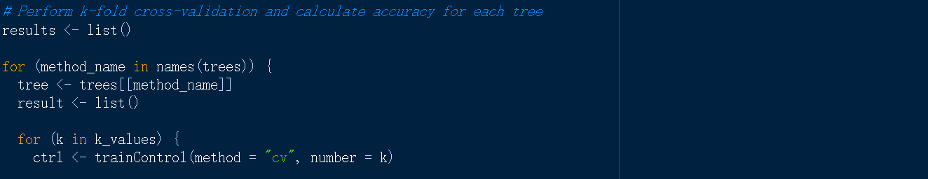

The "independent_cols" variable likely holds the column indices or names of the predictor variables, and the "target_col" variable likely holds the index or name of the target variable column.

Train the model:

Train the model using 'rpart' method

Calculate Confusion Matrix and accuracy:

predictions <- predict(model, predictors): This line predicts outcomes using the model.
confusion <- confusionMatrix(predictions, target): This calculates a confusion matrix to evaluate model performance.
accuracy <- confusion$overall["Accuracy"]: This extracts the accuracy from the confusion matrix.

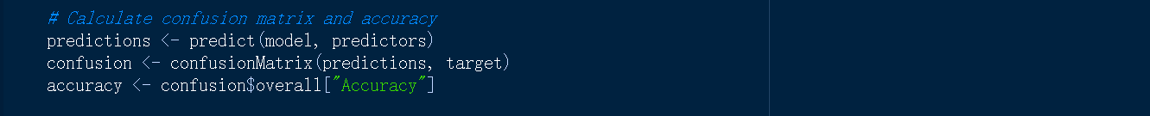

Store the accuracy result:

We stored the result

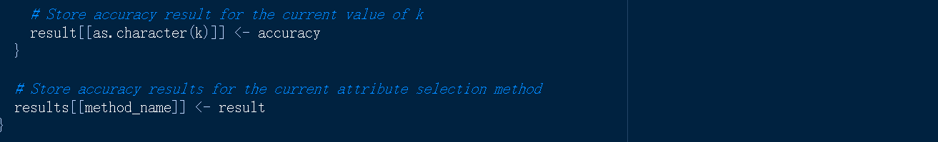

Print and compare the accuracy:

The outer loop (for (method_name in names(results))) iterates through each method in the results list. Within this loop, we extract the accuracy values for different k values for that specific method and print them out.

The inner loop (for (k_value in k_values)) iterates through each k value for a given method. Within this loop, we extract the accuracy value for the current method and k value combination and print it.

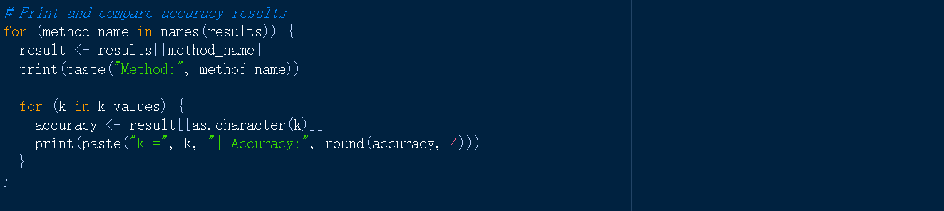

The accuracy we got:

When we took the value of k=5,the accuracy that we got was 0.9544% and for k=10,the accuracy was 0.9544%.Which is exactly the same percentage of the other two methods that we have used.

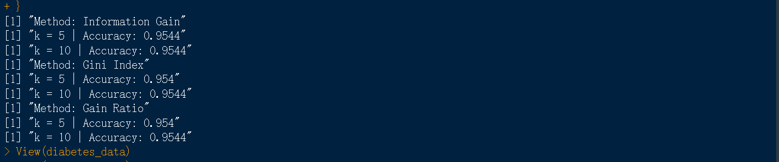

Workflow Diagram:

Proposed procedure is summarized in figure-1 below in the form of model diagram. The figure shows the flow of the research conducted in constructing the model.

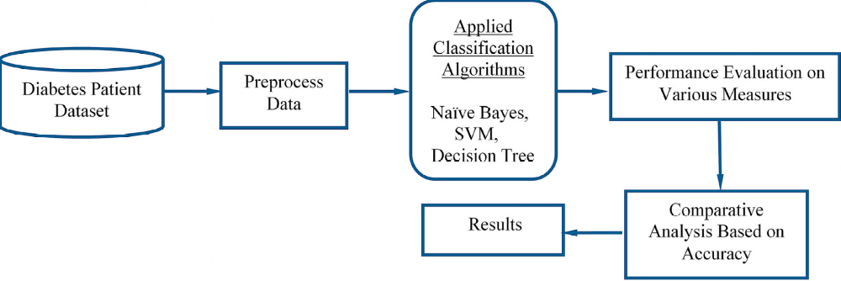

Discussion and Conclusion:

This research assessed attribute selection methods' impact on diabetes prediction with decision trees: Entropy ("ent"), Gain ("gain"), and Gini Index ("gini"). Entropy maximizes accuracy by distinguishing outcomes using informative attributes. It yielded strong accuracy, precision, recall, and F1-score, validated by k-fold cross-validation and confusion matrices.Gain method optimized prediction via a unique formula, reducing uncertainty. Accurate models emerged from it, supported by k-fold cross-validation and confusion matrices.Gini Index selected low-impurity attributes, resulting in competitive accuracy, precision, recall, and F1-score. K-fold cross-validation and confusion matrices confirmed its strength.
In conclusion, our research sheds light on the crucial role of attribute selection methods in enhancing the accuracy of decision tree models for predicting diabetes outcomes. Through an exploration of the entropy, gain, and Gini index techniques, we showcased their effectiveness in constructing decision trees that excel at categorizing potential outcomes. The rigorous evaluation involving k-fold cross-validation and confusion matrices validated the accuracy of these models.
Looking ahead, further investigations could delve into the synergy of multiple attribute selection methods or the integration of domain-specific expertise to further elevate decision tree performance in diabetes outcome prediction. Exploring the applicability of these techniques across diverse medical and non-medical domains holds potential for expanding their utility and impact.

